Methodical instructions to laboratory work 2

STUDY OF MULTYPROCCESORS SYSTEMS (SMP) WITH GENERAL (SHARED) MEMORY

Purpose of work. Analysis of functionality and efficiency of multiprocessors systems (SMP) with general (shared) memory.

General information
Multiprocessor systems are parallel systems realized large-grain and medium-grain concurrency. Each task (aplication) can be divided on the set independent sub-tasks which execute on the various processors in parallel. Really applications have consistent-parallel nature. Therefore somet of sub-tasks can be performed in parallel and some of them consistently.
Multiprocessor systems have distributed control. Today these systems with general or shared memory called SMP (symmetric multiprocessors) systems.
Firstly we consider characteristics of SMP systems. Data transfer in SMP systems perform by memory. It’s fast data exchange. The main disadvantages of these systems are memory conflicts and limited scaleability. We consider the main structures of SMP systems.
The first structure of SMP system is shown in fig.1

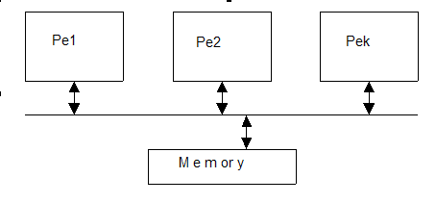

Fig.1. Structure of multiprocessor system with general memory

In this case all PE have general memory and shared memory access. So at the same time only single PE can address to memory. Advantage of this structure is fast data transfer. Disadvantage is in time delay because of PE conflicts as to memory access. Time delay increases with growth of processors number. Using of cache in PE can decrease this disadvantage.
So the second structure of SMP system is shown in fig.2
Cache of each PE can use for storage their own programs and untermediate data. Thus general memory uses only for data that need multiple PE. Advantages of this structureare in fast access to cache, parallel access PE to their own caches and decreasing access number to general memory. But in this case at the same time also only single PE can address to memory. So if we have a lot of general data for multiple PE, number of memory conflicts can still great. Decreasing of them is connected with using shared memory which consists of local-address memory banks.

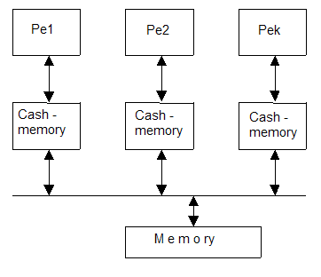

Fig.2. Structure of SMP system with general and cache memory

Structure of this SMP system is shown in fig.3

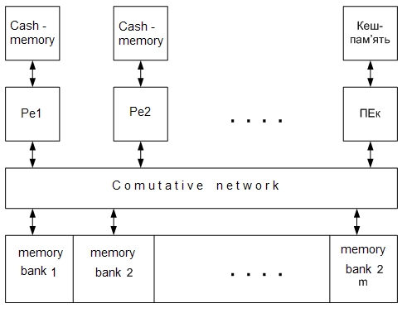

Fig.3. Structure of SMP system with shared memory consists of the locally-addressed spaces banks

In this case at the same time m PE can address to various banks data in parallel.We have conflicts only in the case when various processors need access to the single memory bank. Interconnected net uses for connection PE with various memory banks. This is structure of modern SMP system and it provides minimal memory conflicts number.

Laboratory work task
Initial data:

- Application (таbl.1) , matrix dimension equals to 4 or 5;
- coef. α and β values (таbl.1)

Task is in following:

1) Create parallel processing graph for application where nodes are sub-tasks and edges are connections between dependent sub-tasks;
2) Determine value of Т_{о} (in tacts) for every sub-task of application, if t₊=1 tact; t*= * t₊, t/=*t₊;
3) perform optimal assigning (sheduling) sub-tasks on processors of SMP systems (fig.3) with various number of processors ( from 2 up to graph width). Use program simulation PLASMA;
4) Determine execution time, speedup and application efficiency for various number of SMP systems;
5) Compare efficiency measures of SMP systems with “hand” and “automatic” sheduling in PLASMA.
6) Choose optimal number processors of SMP for using application and perform analysis results of SMP system working.

Таbl.1
Variant  № | APPLICATION | Coef.  α | Coef.  β
1 | Matrix multiplication | 2 | 3
2 | Linear system execution with Kramer method | 3 | 4
3 | Linear system execution with Gauss method | 2 | 4
4 | LU-decomposition of matrix | 3 | 5
5 | Linear system execution with simple iteration (Jacobi’s) method | 2 | 5
6 | Linear system execution with Gauss-Seidel iterations method | 2 | 4
7 | Linear system execution with square roots method | 4 | 5
8 | Linear system execution with Choleski method | 3 | 5
9 | Nonlinear system execution with Nuton method | 2 | 3
10 | Back matrix definition | 2 | 4

